Test Legend:

| **Parameter** | **Test 1** | **Test 2** | **Test 3** | **Test 4** |
| --- | --- | --- | --- | --- |
| Agent | 50 | 50 | 50 | 100 |
| Neighborhood Size | 10x10 | 25x25 | 50x50 | 10x10 |
| Movement Size | 1 Unit | 1 Unit | 1 Unit | 1 Unit |
| Search Radius | 5 Unit | 5 Unit | 5 Unit | 5 Unit |
| Attraction (F)/ Similarity(T) | T/F Sweep | T/F Sweep | T/F Sweep | T/F Sweep |
| Familiarity | T/F Sweep | T/F Sweep | T/F Sweep | T/F Sweep |

**(all videos included in separate folder)**

**Test 1**

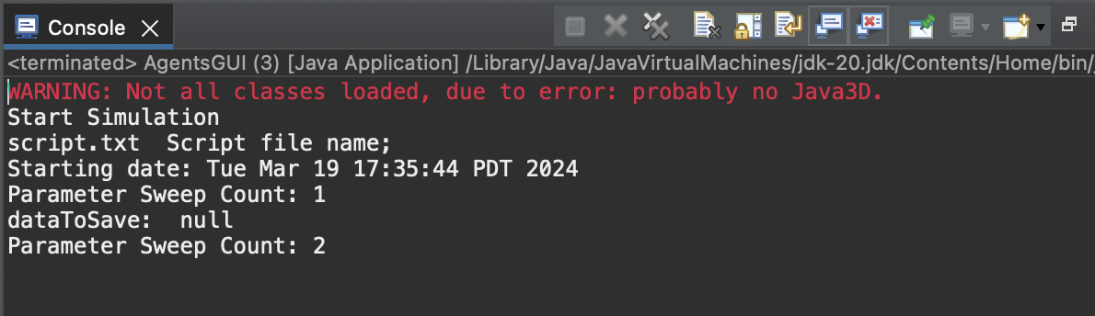

* Video Name: test 1
* Neutral run, no changes
* Hypothesis: We expect familiarity to decrease mate-search times across all sexual orientations. Alternatively, we expect non-heterosexual sexual orientations to increase mate-search times.

**Test 2**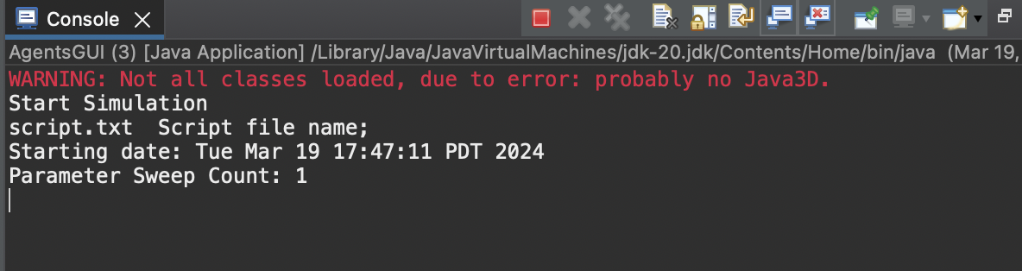

* Video Name: test 2
* Changed neighborhood size to 25x25
* Hypothesis: Increased neighborhood size will increase the initial amount of familiar agents, thereby spatially decreasing mate time.

**Test 3**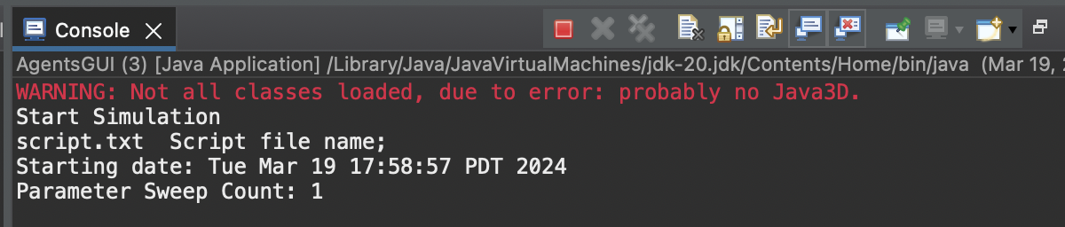

* Video Name: test 3
* Changed neighborhood size to 50x50
* Hypothesis: Familiarity will be a leading predictor of mate speed due to the much larger size of neighborhoods. Similarity and attractiveness will not be the main drivers behind mate choice.

**Test 4**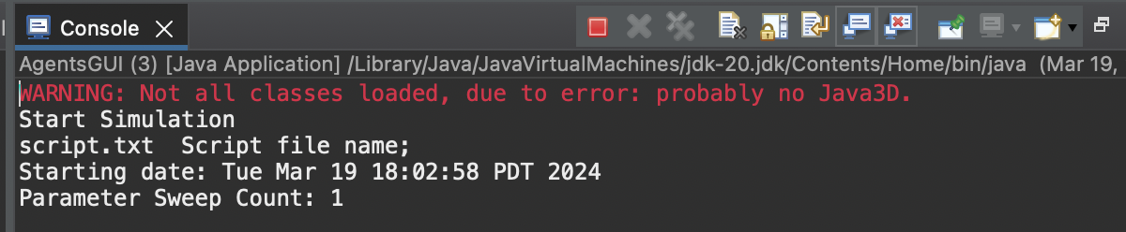

* Video Name: test 4.mov
* Changed agent population to 100
* Hypothesis: Mating speed will decrease due to more agents being readily available. More agents will also decrease familiarity across all agents since there are more agents to interact with and rate of re-encountering interactions will decrease.